**App Name:** Gamebook

**Task:** “Select Favorit Team game”, “View game players” and “View team game score”

**Student Name (Expert):** Edgar Caruço

**Nielsen Heuristic:** H4. Consistency and standards

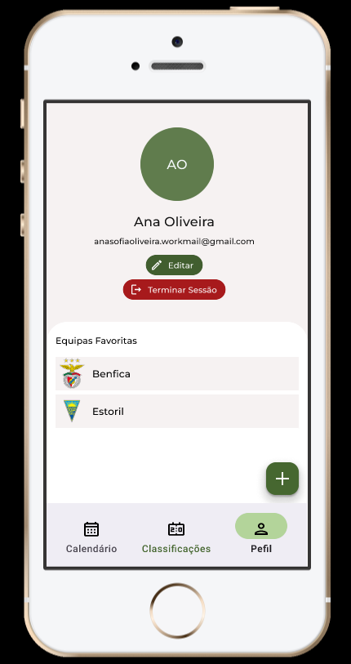

**Problem:** Log out hided on user profile

**Heuristic:** H4. Consistency and standards

**Description:** The user need to go to the user profile to be able to log out

**Correction:** Implement a menu on profile button with the options to log out and/or see the user profile

**Severity:** 2 - Minor usability problem